**Converging Blockchain and Machine Learning for Healthcare**

**ABSTRACT:**

As a common indirect factor model, the Matrix Factorization (MF) has demonstrated its best performance in defector Systems. Users and items are represented in low-dimensional intervals shared so that user preference can be modeled straight away The user-specific coefficient that connects the item factor vector V From two independent Gaussian distributions, this is not true of reality. Users meet the maximum number of users' U and V are strongly related requirements. In the meantime, the linear mixture between U and V becomes a binary (One-to-one mapping), bypassing the mutual connections between hidden factors. In this sheet, we talk over Problems, and propose a new model, called Correlated Matrix Factorization (CMF). Technically, we use a relationship relationship.An analysis (CCA) to connect to U and V as a new discourse. One component, except for the ideal matrix to reach the optimum match In each direction (U or V) the other is closely related to each element. We get efficient evaluation and learning Instructions based on different EM methods. The performance of our proposed model was fully validated by four general public Datasets. Test results show that our approach achieves competitive effectiveness in accuracy and efficiency In comparison with the current level of art.

**ARCHITECTURE:**

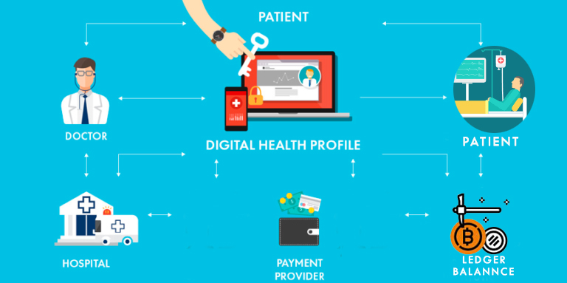

**EXISTING SYSTEM:**

In present systems there is hardly any medical service available in remote locations. Persons needing medical services often need to travel long distances. Even in urban areas the service is sometimes not available immediately. Patients and doctors are hardly to communicate with each others.And also patients had to wait for long time in order to communicate to the doctor. This main concern has to do with the confidentiality of the data. There is also concern about non-confidential data however such Systems that deal with these transfers are often referred to as Health Information Exchange.

**PROPOSED SYSTEM**

Machine Learning can be used in identification of Treatment, give personalized suggestion to Patient, Outbreak Prediction etc.. User can get disease summary on the basis of symptoms entered. Tokenization, removal of stop words and stemming are used as preprocessing. Many techniques have been done in this area which include SVM classifier, Naive Bayes and Decision Trees. The best result obtained has the accuracy percentage of 98.51%. The machine learning algorithm can also give lifestyle suggestion to Patient on the basis of current medical situation and medical history. The machine learning models can be trained to predict future outcomes The consensus in Blockchain technology makes sure that data is legitimate and secured. The convergence of these two technologies can give highly accurate results in terms of machine learning with the security and reliability of Blockchain Technology. This paper gives an overview of how combining these two technologies can help in healthcare sectors

**MODULES:**

* System Framework
* Doctor
* Patients
* Blockchain
* Transaction manager
* Machine learning

**MODULES DESCRIPTION:**

**System Framework:**

The development of Machine Learning and the popularity of Machine Learning devices, people are gradually getting accustomed to a new era. Blockchain Technology got recognition from Bitcoin cryptocurrency. The block is marked with previous block’s hash and timestamp and will be added to the existing blockchain. The block is permanent and unaltered. people (patients) can upload their documents and share these data with doctors (doctor) they like to solve. Doctors can be trained to predict future outcomes. data files are sensitive, Doctors are allowed to choose the patients data with specific people (patients). Clearly, dataprivacy of the personal sensitive data is a big challenge manage by transaction manager.We gives an overview of how combining these two technologies can help in healthcare sectors. (1)doctor (2) patients (3) transaction manager (4) Blockchain (5) Machine Learning

**Doctor:**

the model can predict outbreak and can give suggestion to the doctor. In healthcare sectors, we use lots of machines and equipments to perform any medical test. Every machine or part of machine has its own life span. It can also predict the need to change/remove the machine or a part of machine. Every authenticated user will have copy of shared ledger. This will resolve data acquisition problem. The machine learning models can be directly fed with data which will be highly reliable and results can be retrieved. The best result obtained has the accuracy percentage of 98.51%. The machine learning algorithm can also give lifestyle suggestion to Patient on the basis of current medical situation and medical history.

**Patients:**

The model can be trained on the basis of suggestions given to other patients (by doctors) having same problems or symptoms. The Patient can get lifestyle advice. On the basis of Patients symptoms, the trained model can give clinical suggestions to doctors. The model can be trained with real data. This will increase the efficiency and accuracy of models thereby reducing the additional cost to be paid to central authority.If a patient does any basic enquiry regarding his/her health, the trained model with the help of Natural Language Processing can identify the disease as well as give treatment suggestion.

**Blockchain:**

Blockchain Technology got recognition from Bitcoin cryptocurrency which was described in Satoshi Nakamoto’s whitepaper in 2008. This can be explained as, if someone in the blockchain network initiates a transaction. The transaction will be broadcasted in the P2P network called as nodes. The nodes will validate the transaction. If the transaction gets verified, it will be combined with other valid transaction to form a block. The block is marked with previous block’s hash and timestamp and will be added to the existing blockchain. The block is permanent and unaltered. It has no problem of single point of failure and there is no central server to manage the network

**Transaction manager:**

Every user in the Blockchain network will get an authorized certificate from Certificate Authority. It will going to provide identity to the user who will going to transact in the network. The identity will be digital certificate. The digital certificate will be used by the user to sign the transaction and submit it to the blockchain. The benefits of signing are: a. Authenticate the blockchain that the user performing or requesting any transaction is a legitimate user. b. Ensuring that user has rights to access the ledger for the transaction they are performing. For instance, Patient will get certificate from the authority. The Patient can access his/her own details but will not be eligible to access the details of other patients. Patient will not be eligible to view details regarding other activities.

**Machine learning**

Machine learning has been extensively used to benefit healthcare. Machine Learning can be used in identification of Treatment, give personalized suggestion to Patient, Outbreak Prediction etc.. User can get disease summary on the basis of symptoms entered [10]. Tokenization, removal of stop words and stemming are used as preprocessing. Many techniques have been done in this area which include SVM classifier, Naive Bayes and Decision Trees. Neural Network with SVM was used to predict outbreaks of malaria in Maharashtra State. The model took rainfall, temperature, other reported cases in the area and other medical details to predict the outcome. The major hindrance in machine learning applications is data acquisition [6]. Researchers have to do a lot of struggles to get appropriate data. Lack of proper data leads to inefficient models that reduces the accuracy percentage